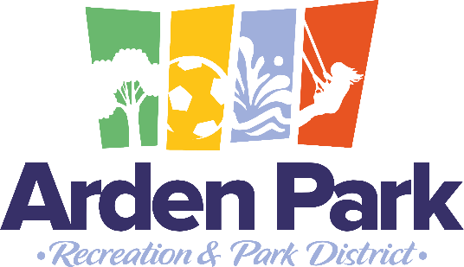

ARDEN PARK RECREATION AND PARK DISTRICT
1000 La Sierra Drive
Sacramento, CA 95864
(916) 483-6069

Board of Directors
Chair Rebecca Akroyd
Brian Weatherford
Nora Shetty
Lauren Erickson
Robert Lemmon

AGENDA
SPECIAL MEETING OF THE BOARD OF DIRECTORS
April 7, 2026
6:00 pm – Arden Park Community Center

This meeting will be held at the above-stated location. This location is accessible to the public, and a member of the public may address the Board of Directors at this location. In compliance with the Americans with Disabilities Act, if you are a disabled person and you need a disability-related modification or accommodation to participate in this meeting, please contact the District office at (916) 483-6069. Requests should be made as early as possible, and preferably at least one full business day in advance of the start of the meeting. Documents and materials related to an open session item on this agenda submitted to this Board after distribution of the agenda packet are available for public inspection and copying at The District office located at the address listed above during normal business hours.

- CALL TO ORDER
    - Welcome
    - Roll Call and Announcement of a Quorum
    - Agenda Approval
- PUBLIC REQUEST TO ADDRESS THE BOARD OF DIRECTORS
    - Any member of the public who requests to address the Board on any item which is not on the agenda may do so at this time. Any matter that requires action by the Board will be referred to the staff for action or staff will be asked to report back to the Board at a subsequent meeting. Comments pertaining to scheduled agenda items will be heard when that item is discussed by the Board. Comments are limited to three minutes per person unless further time is granted by the presiding officer.
- CLOSED SESSION
    - Closed Session pursuant to Government Code Section 54957 (b) Public Employment-General Manager
- REPORT FROM CLOSED SESSION
    - Discussion and possible action to appoint a new general manager
- ADJOURN

This agenda has been prepared as required by the applicable laws of the State of California, including but not limited to, Government Code Section 54954.2(a)(3). No action or discussion shall be undertaken on any item not appearing on the posted agenda, except that members of a legislative body or its staff may briefly respond to statements made or questions posed by persons exercising their public testimony rights under Section 54954.3. In addition, on their own initiative or in response to questions posed by the public, a member of a legislative body or its staff may ask a question for clarification, make a brief announcement, or make a brief report on their own activities. Furthermore, a member of a legislative body, or the body itself, subject to rules or procedures of the legislative body, may provide a reference to staff or other resources for factual information, request staff to report back to the body at a subsequent meeting concerning any matter, or take action to direct staff to place a matter of business on a future agenda.

